**Project Design Phase-II**

**Data Flow Diagram & User Stories**

|  |  |
| --- | --- |
| Date | 6 March 2025 |
| Team ID | SWTID1741257978145975 |
| Project Name | COOK BOOK |
| Maximum Marks | 4 Marks |

**Data Flow Diagrams:**

A Data Flow Diagram (DFD) is a traditional visual representation of the information flows within a system. A neat and clear DFD can depict the right amount of the system requirement graphically. It shows how data enters and leaves the system, what changes the information, and where data is stored.

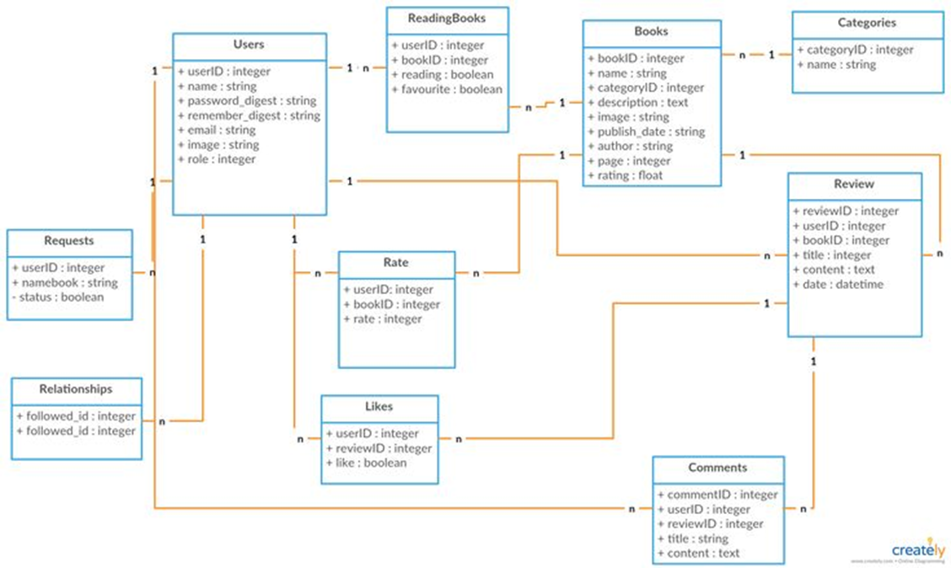

**Your Virtual Kitchen Assistant:**

|  |  |  |  |  |  |
| --- | --- | --- | --- | --- | --- |
| | **User Type** | **User Story Number** | **User Story / Task** | **Priority** | **Release** | | --- | --- | --- | --- | --- | |
| |  |  |  |  |  | | --- | --- | --- | --- | --- | | **Customer** | **USN-1** | **Search for recipes and view instructions.** | **High** | **Sprint-1** | |
| |  |  |  |  |  | | --- | --- | --- | --- | --- | | **Customer** | **USN-2** | **Upload recipe images and manage recipes.** | **High** | **Sprint-1** | |
| |  |  |  |  |  | | --- | --- | --- | --- | --- | | **Customer** | **USN-3** | **Get personalized recipe recommendations.** | **Low** | **Sprint-2** | |
| |  |  |  |  |  | | --- | --- | --- | --- | --- | | **Customer** | **USN-4** | **Create and manage a shopping list.** | **Medium** | **Sprint-2** | |
| |  |  |  |  |  | | --- | --- | --- | --- | --- | | **Customer** | **USN-5** | **Save favorite recipes.** | **High** | **Sprint-1** | |
| |  |  |  |  |  | | --- | --- | --- | --- | --- | | **Customer** | **USN-6** | **Filter recipes by preferences.** | **Medium** | **Sprint-2** | |
| |  |  |  |  |  | | --- | --- | --- | --- | --- | | **Admin** | **USN-7** | **Manage user accounts and content.** | **High** | **Sprint-1** | |
| |  |  |  |  |  | | --- | --- | --- | --- | --- | | **Admin** | **USN-8** | **View analytics and platform usage.** | **Medium** | **Sprint-3** | |